GIT Branching Assignment 2

Objective: Commit HTML, CSS & JavaScript assignments into GIT.

SECTION-1 (HTML assignments) - Steps to follow:

1. First take a backup of your assignments & projects. This is required because due to incorrect GIT operation you may lose your files.
2. Create an empty directory ‘Assignments’ & cd to ‘Assignments’.

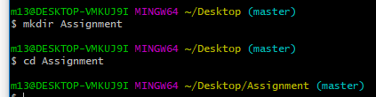

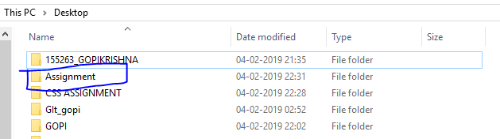

1. Create a file README.txt inside ‘Assignments’ & write few lines about the contents of ‘Assignments’ folder.



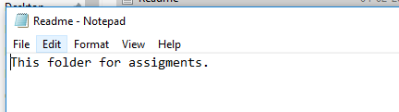

1. Commit README.txt file.

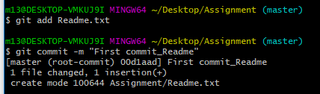

1. Now create a new branch ‘html-assignments’.

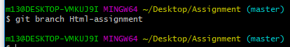

1. Switch to ‘html-assignments’ branch.

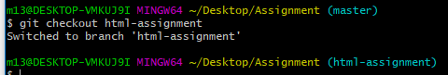

1. Copy all HTML assignments inside ‘Assignments’ folder.

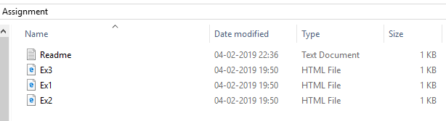

1. Commit HTML assignments into ‘html-assignments’ branch.

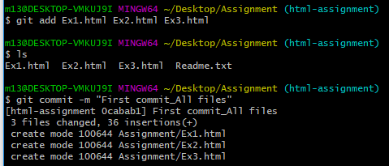

1. Make minor changes into few files belonging to ‘html-assignments’ branch

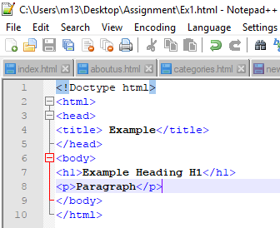 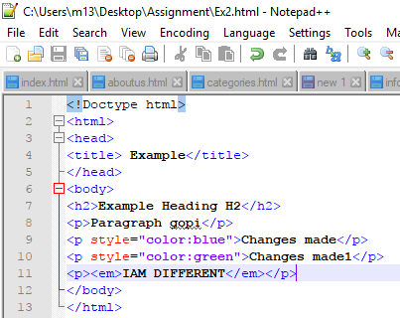

1. Commit those changed files.

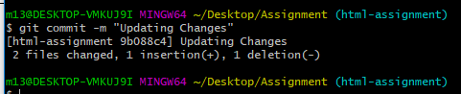

1. Switch to master branch.

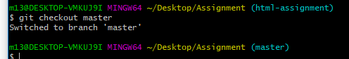

1. Make minor changes into README.txt file & commit those changes into master.

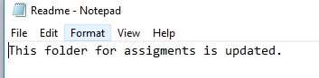

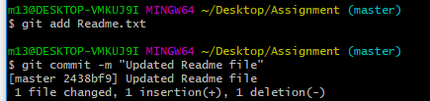

1. Again switch to ‘html-assignments’ branch.



1. Make minor changes into few files belonging to ‘html-assignments’ branch.

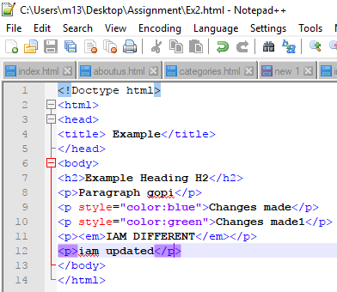 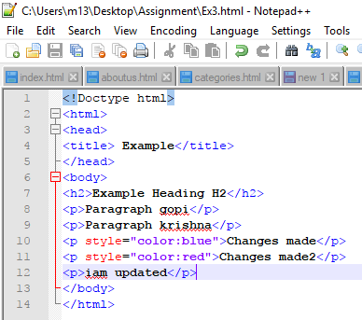

1. Commit those changes.

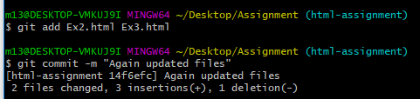

1. Switch to master.

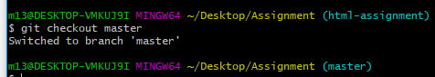

1. Merge ‘html-assignments’ branch into master. Confirm all html assignments are shown in master.

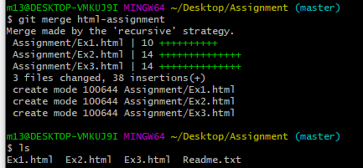

1. Finally delete the ‘html-assignments’ branch.

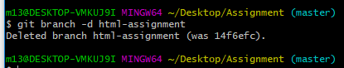

SECTION-2 - (CSS assignments) Steps to follow:

1. Create a new branch ‘css-assignments’.



1. Switch to ‘css-assignments’ branch.



1. Copy all CSS assignments inside ‘Assignments’ folder.

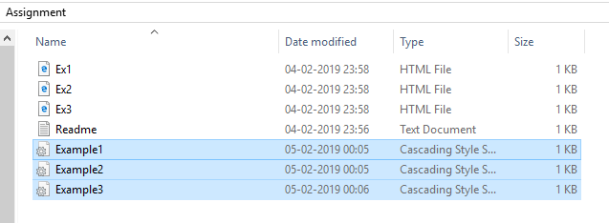

1. Commit CSS assignments into ‘css-assignments’ branch.

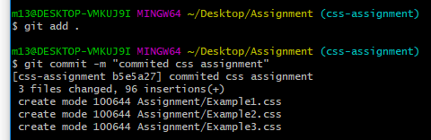

1. Make minor changes into README.txt file on line 1 belonging to ‘css-assignments’ branch.

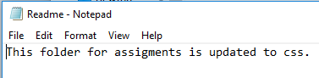

1. Commit those changed files.

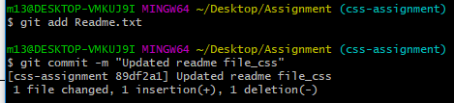

1. Switch to master branch.



1. Make minor changes into README.txt file on line 3 & commit those changes into master.

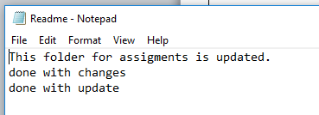

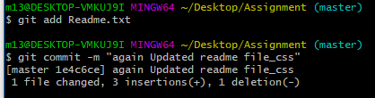

1. Again switch to ‘css-assignments’ branch.



1. Make minor changes into few files belonging to ‘css-assignments’ branch.

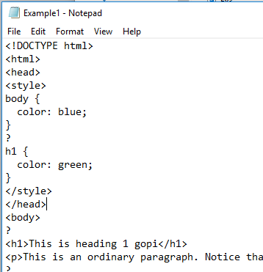 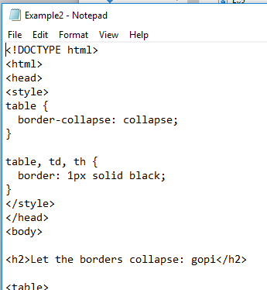

1. Commit those changes.

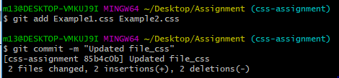

1. Switch to master.



1. Merge ‘css-assignments’ branch into master. Confirm all css assignments are shown in master.

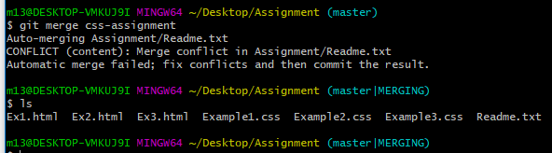

1. Finally delete the ‘css-assignments’ branch.



SECTION-3 - (JavaScript assignments) Steps to follow:

1. Create a new branch ‘js-assignments’.



1. Switch to ‘js-assignments’ branch.



1. Copy all JavaScript assignments inside ‘Assignments’ folder.

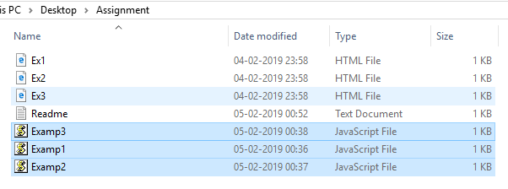

1. Commit JavaScript assignments into ‘js-assignments’ branch.

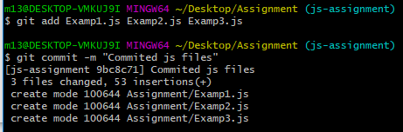

1. Make minor changes into README.txt file on line 1 belonging to ‘js-assignments’ branch.

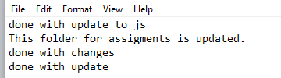

1. Commit those changed files.

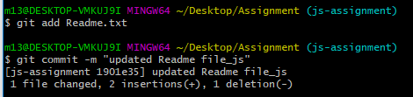

1. Switch to master branch.



1. Make minor changes into README.txt file on line 1 & commit those changes into master.

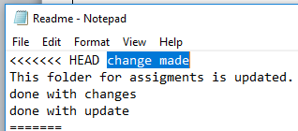

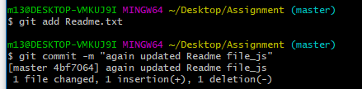

1. Again switch to ‘js-assignments’ branch.



1. Make minor changes into few files belonging to ‘js-assignments’ branch.

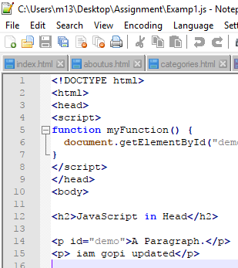 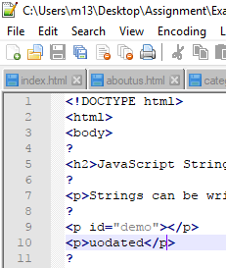

1. Commit those changes.

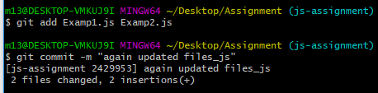

1. Switch to master.



1. Merge ‘js-assignments’ branch into master. Confirm all JavaScript assignments are shown in master.

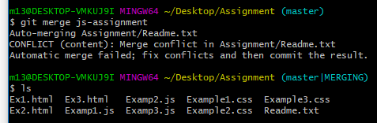

1. Finally delete the ‘js-assignments’ branch.

